University of Kent

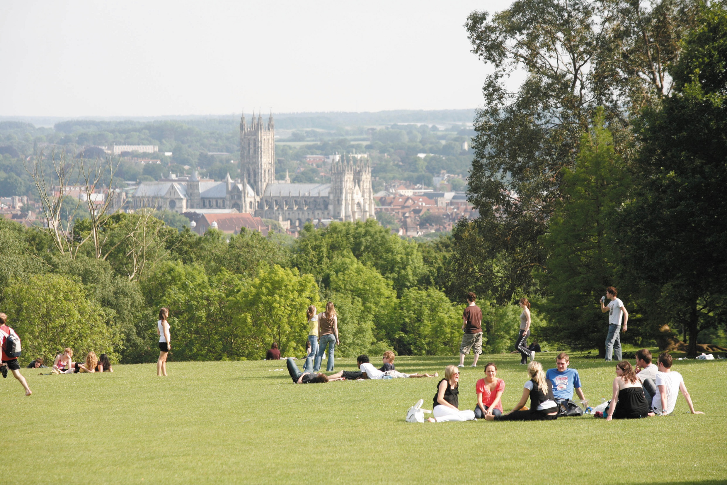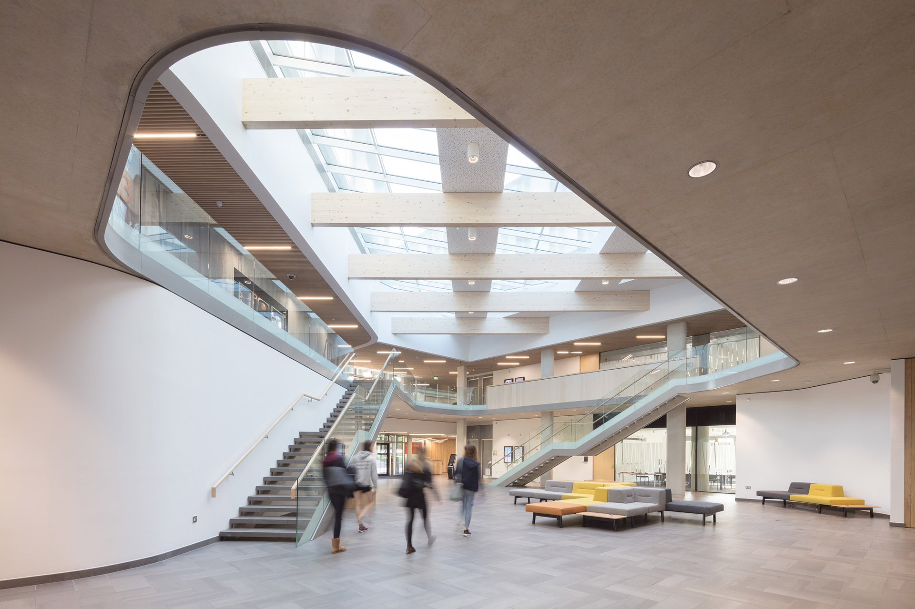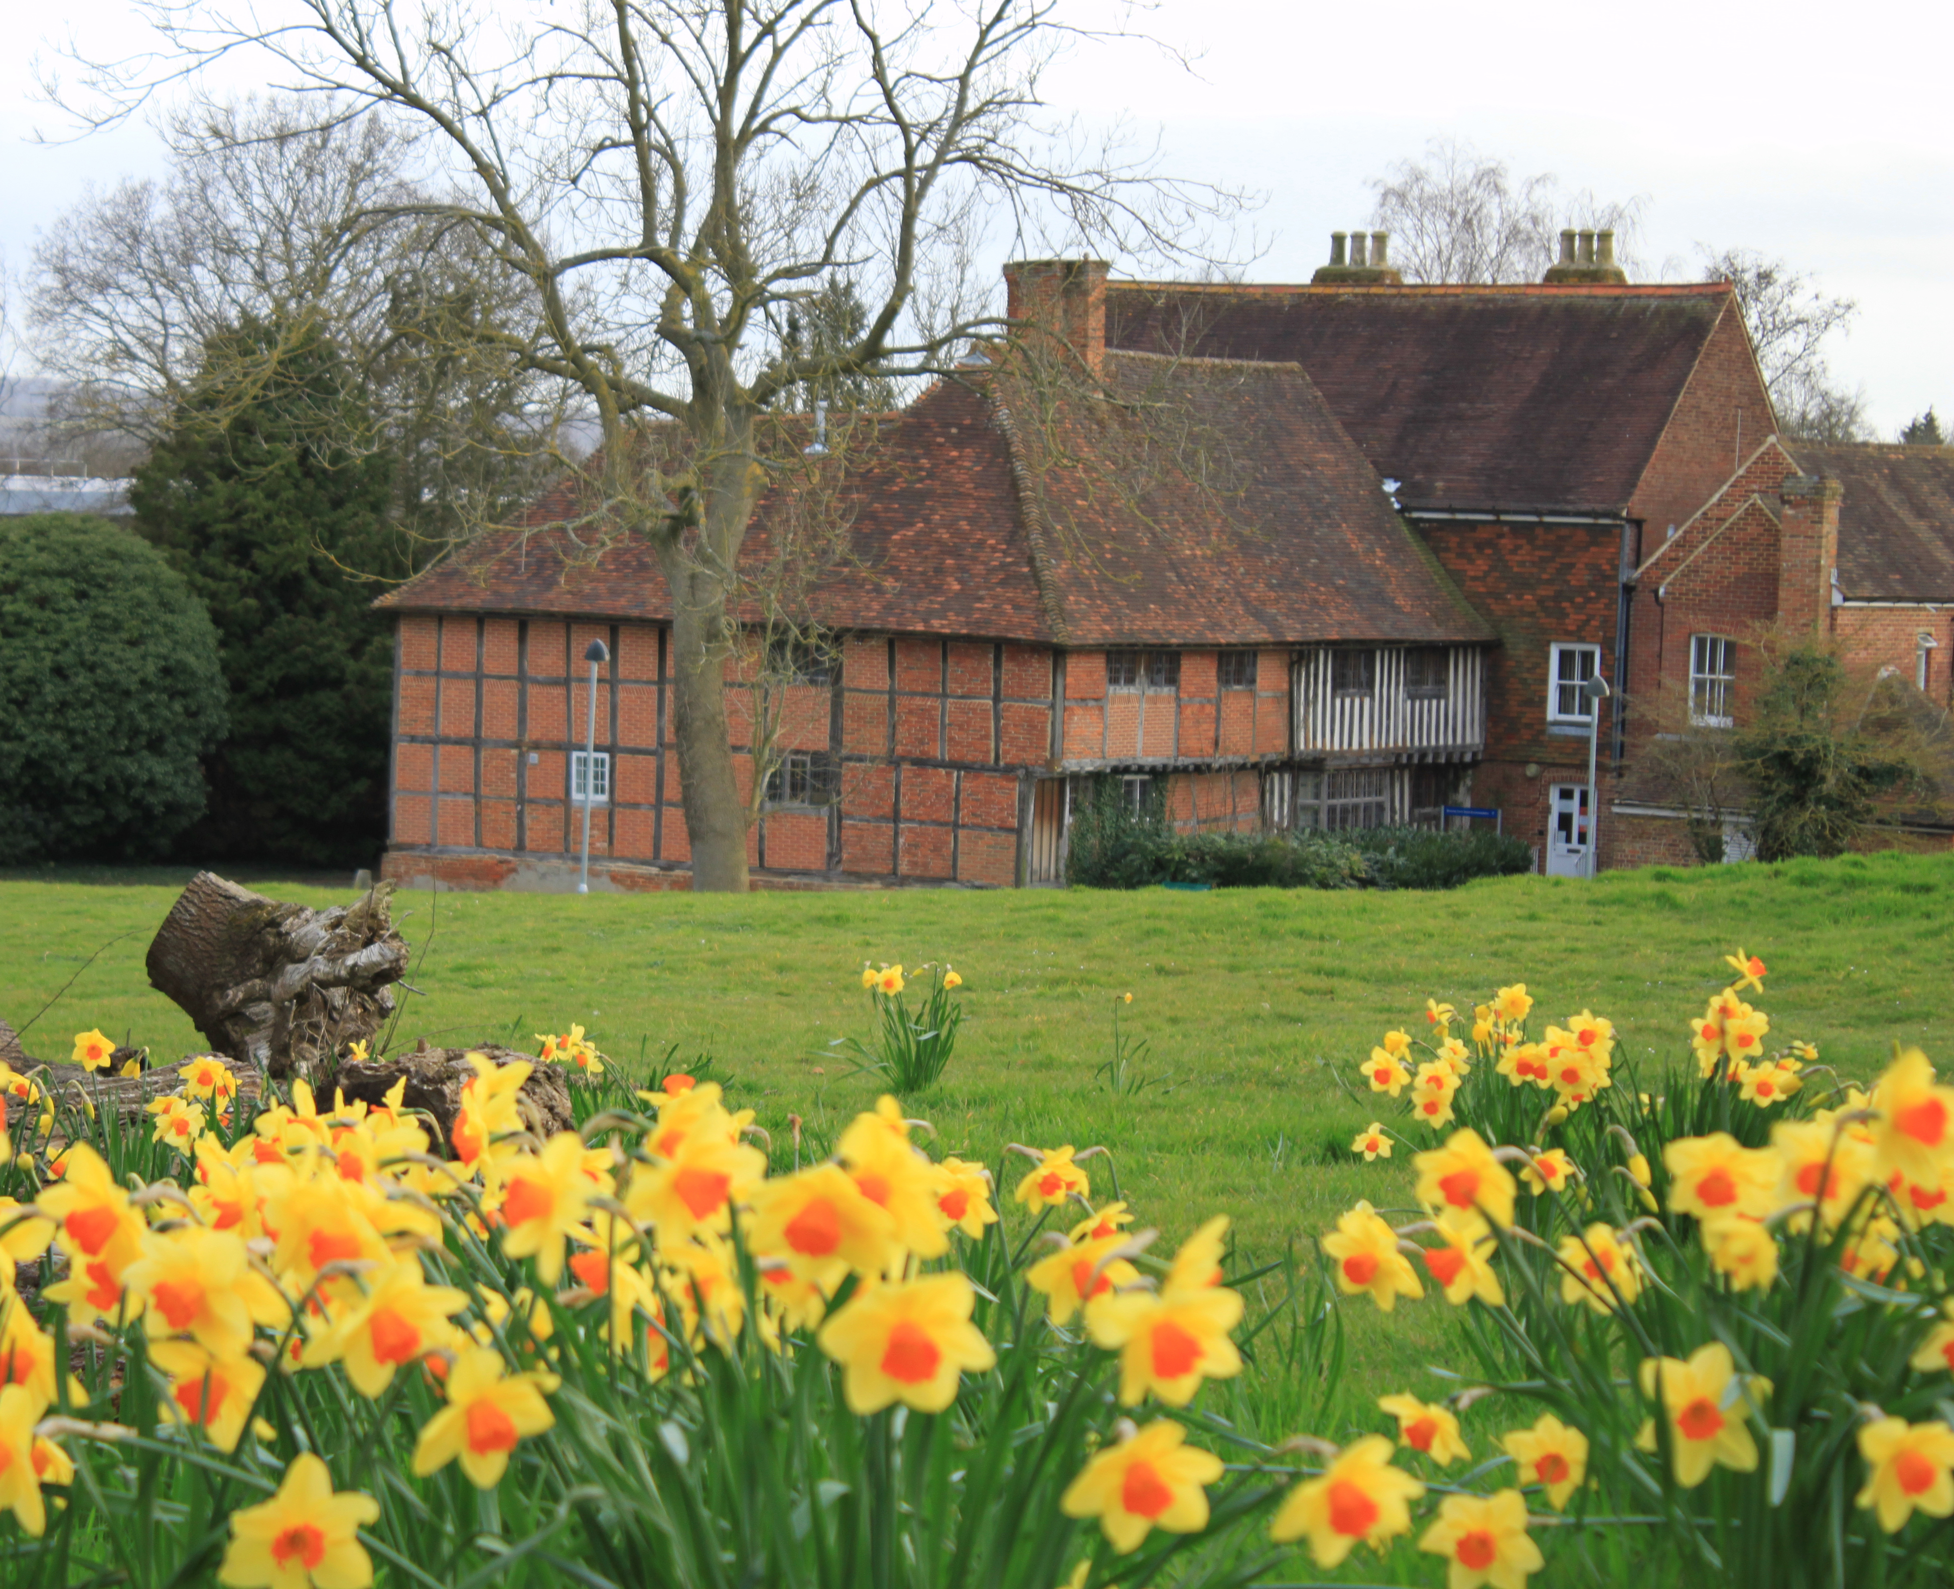

Set in over 300 acres of beautiful parkland overlooking the historic city of Canterbury and its iconic Cathedral. The University of Kent's fantastic location, range of accommodation and extensive facilities make a perfect choice for groups, conferences and events.
With over 5,000 bedrooms available including en-suite, single and double room options, and over150 conference rooms and event spaces ranging from impressive 500 seat lecture halls and performance spaces to smaller break out or meeting rooms, there is an array of spaces to choose from. With superb on-site catering, sports and leisure facilities, including a gym, an Indoor Tennis and Events arena, a theatre and a cinema, your delegates won't have to leave site to enjoy some leisure time too.
For more information please visit: -
https://www.kent.ac.uk/conferences-and-events

